
Comprehensive plan for the identification, activation,
incubation and expansion of ideas with high potential
for innovation.

CONTENTS OF THE REPORT
- DEFINITION OF THE PLAN
- AIMS OF AGROTECH START UP PLAN
- REGIONAL CHALLENGES IN ATTRACTING STARTUPS
- AGROTECH START UP CASH DELIVERIES WITHOUT COMPENSATION
- ACCELERATION MODEL
Author: | Extremadura Avante Innovación
Date: | [02/25/2015]

- AGROTECH EXTREMADURA SPECIALISATION
Agrotech is the Master Plan for Economic Policy in Extremadura until 2020, which is applied under the Research and Innovation Strategies for Smart Specialisation (RIS3) framework in Extremadura. It is a new production model for Extremadura based on the development, exploitation and commercialization of the technology linked to the rural environment. "Agro" is synonymous with the rural environment, and reflects an identity and tradition, and "Tech" symbolises opportunity and progress; all this together results in taking advantage of Extremadura's existing abilities in order to enter a select group of emerging markets.
Terms such as technology and innovation are not traditionally associated with rural areas. Agrotech is Extremadura’s commitment to technologies that promote social welfare not only in cities, but especially in every rural settlement through the support of the agri-food industry, education and health.
Extremadura will lead the generation of goods, products and services derived from robotics, microelectronics, TICs, genomics, new educational systems or telemedicine, which allow a social and territorial cohesion in order to:
- Improve the quality of life and work of the citizens in rural areas.
- Strengthen the value creation in the rural economy, both in traditional and new sectors.
- Enable the full integration and participation of rural areas in a knowledge-based economy.
- Increase the competitiveness of companies from Extremadura.
- Bridge the gap between rural and urban populations.
- DEFINITION OF AGROTECH STARTUP PLAN
Entrepreneurship based on opportunity and innovation presents higher rates of wealth generation and employment opportunities in a sustainable way, and it succeeds in progressively transforming the territory’s productive fabric, providing it with a new economic identity that remains in the long term.
However, this entrepreneurship presents a high-risk in the early stages of its life cycle. Achieving success in changing this production model from a clear commitment to ideas of highly innovative projects and with high growth potential (Startups) therefore entails assuming and managing the level of risk associated with it.
With this in mind, the Regional Government of Extremadura started AGROTECH STARTUP, a comprehensive plan for the identification, activation, incubation and expansion of ideas with high potential for innovation as a source of generation of competitive advantages, attraction and retention of talent, and quality employment in the medium and long term. This is a plan resulting from the coordination of existing resources and abilities in the region in the fields of science, technology and innovation, the development of partnerships with the best national and international stakeholders (Telefónica Open Future, Microsoft, Spain StartUp South Summit, and so on), technical support and highly specialized services.

- AIMS OF AGROTECH START UP PLAN
To enable entrepreneurs and companies to develop their business models based on innovation and to address the challenges, the Regional Government of Extremadura will support 100 new Agrotech StartUps in the 2015 edition with a maximum amount of € 50,000 per initiative to cover costs for an 8-month acceleration plan.
The main aims of "AGROTECH STARTUP" will be:
- To identify projects with high innovation potential likely to develop successfully in Extremadura.
- To create partnerships with people, companies and key institutions to provide relationships, resources, services and reference contents to the process.
- To coordinate the different resources and abilities in the public sector to make up a service portfolio for the most innovative projects.
- To create an attractive territory for the entrepreneurial talent in our fields of specialisation.
- To support the model of regional development based on the innovative entrepreneurship with high growth potential.

REGIONAL CHALLENGES OF EXTREMADURA
In order to make Extremadura into an AGROTECH International Hub, StartUp Extremadura started to identify ideas for projects with high potential for innovation and close to market, calling the entrepreneurs to work in tackling the identified challenges.
It is possible to find these challenges in the https://extremadura.openfuture.org tool. After a first pilot project where 12 projects were accelerated (from September 2014 to March 2015), this global call initiates the development and growth of projects that aim to participate in the Regional Government’s AGROTECH STARTUP support plan.
Some of these strategic challenges to Extremadura are logistics for the circular economy, post-harvest, biomass and energy efficiency drones: image processing, drones: data storage and transmission, e-health, etc.

- AGROTECH START UP PLAN 2015.
Extremadura Avante Servicios Avanzados a la Pyme S.L.U. published the call for projects on January 8th, 2015, in the Government gazzete of Extremadura (DOE) to select 100 projects to participate in the plan for the activation, incubation and expansion of ideas with high potential for innovation, “AGROTECH STARTUP”.
Through the Open Future platform, nearly 500 unique projects have joined the challenges, and finally 404 of them have applied for the plan. Once filtered, just 316 proposals were suitable for participation.

- ACCELERATION MODEL
Extremadura Avante Servicios Avanzados a Pymes, S.A.U. and the General Secretariat for Science and Technology in the Regional Government of Extremadura are carrying out several agreements with entities and institutions based in Extremadura in order to integrate them in the AGROTECH STARTUP project acceleration process.
A network of accelerators for "AGROTECH STARTUP" projects has been created to provide support for entrepreneurs in the development of their ideas and the creation of their companies. The accelerators are in line with the fields of specialization listed in the Research and Innovation Strategies for Smart Specialisation (RIS3): Agri-food, Renewable Energy, Health, Tourism and ICT.
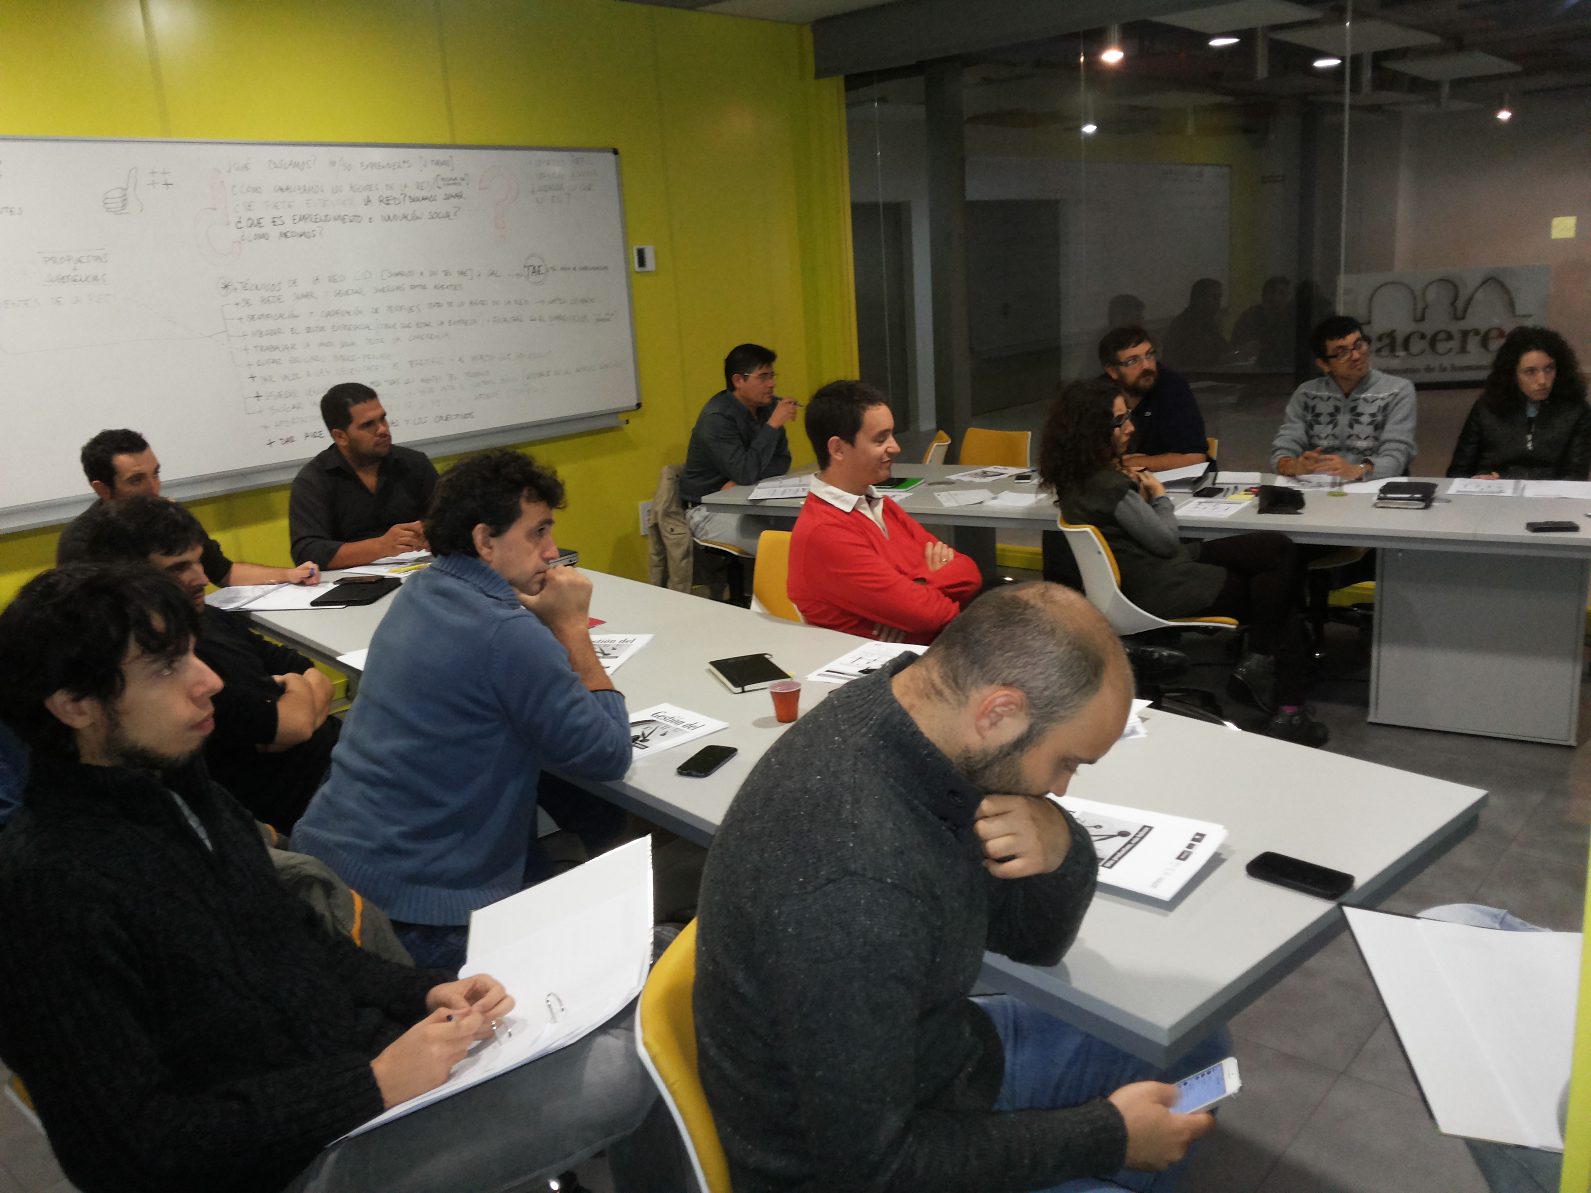

These spaces will house an average of 12 projects and will be located in the following municipalities of Extremadura:
- Badajoz, Parque Científico y Tecnológico y Espacio Convento.
- Cáceres, Garaje 2.0 and Centro de Cirugía de Mínima Invasión Jesús Usón.
- Los Santos de Maimona, Espacio Mainova, Fundación Maimona.
- Almendralejo, Centro de Innovación de Almendralejo.
- Plasencia, Centro de Agricultura Ecológica y de Montaña.
- Don Benito. Centro Feval Agrotech.
The spaces are equipped with the necessary infrastructure for the development of the growth process; furthermore, they will be interconnected to facilitate the networking among different participants in the plan.
The projects will work in accordance with the following Work Plan:
