DRAFT-
Terms of Reference: Standing Committee

Role/Mission of the Standing Committee:

The Standing Committee is designed as an advisory and support body to the NEREUS-Management Board. It comprises multidisciplinary experts with profound knowledge of the space community, activities, capabilities and regional strategy of their respective region. Its members distinguish themselves through a close linkage to the political level as well as the relevant space player (enterprises, clusters, research organizations) in their region’s territories.

In this respect, the main mission of this body is to give expert and forward looking advice to the NEREUS-Management Board and support the implementation of the NEREUS-work program and key initiatives of the network. The Standing Committee will assign one of its members as chair-man. In particular, the Standing Committee is meant to

- Access and evaluate network initiatives from a strategic point of view (considering their regional strategies, the role of regions etc.) and to give expert and forward looking advice to the Management Board;
- Mobilize key player of their region to support/ get involved in relevant network activities (e.g. responses to EU-calls, ESA-projects etc.);
- Channel information on network activities back to their region, support regional anchorage, facilitate a better link and synergies between the activities of their respective region and NEREUS-activities;
- Reflect jointly with the Management Board how outcomes/results of network activities can be better used for their region (optimal exploitation of the potentials of the network for their region);
- The Standing Committee will closely liaise with the NEREUS-working groups;

The ambitious NEREUS work program as well as opportunities for enhanced collaborations with relevant European organizations (ESA, GSA) and large scale regional initiatives with considerable financial volumes demand increasingly more strategic and professional expertise from member regions. In order to respond to these upcoming challenges and implement the related tasks in an efficient manner an increased involvement of the political decision maker and foremost relevant academia and business sector but also clusters of member regions are needed.

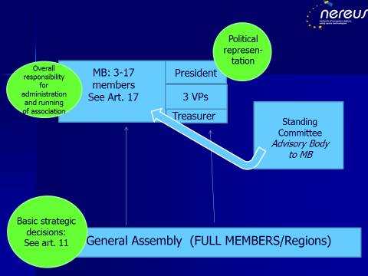

Topics for 2015/2016

- Growing NEREUS-Network, in particular attracting new members and partners; (high priority)
- Better linking regional strategies and space activities with network/network activities
(optimal exploitation of network’s potentials);
- Copernicus-User-Uptake at regional level
  - Activities related to programs/activities of the European Commission (in particular DG-Growth)
    - Up-coming call in Space Horizon2020-Program 2016: EO-2-2016: Downstream services for public authorities (Pre-commercial procurement (PCP)): Mobilization of consortia of interested regions for up-coming Horizon2020-call (PCP-call) (high priority/urgent and matter with highest impact for the network reputation)
    - Promoting activities related to the Copernicus-User-Uptake Framework contract at regional level

  - Activities related to programs/activities by the European Space Agency
    - Development/definition of roadmap/areas of cooperation between NEREUS and ESA/ESRIN and supporting its implementation (e.g. Involving regions in the definition user-requirements for next generation of SENTINEL/Copernicus of the future (2016/2017); Building systematic relationships/partnerships with schools, universities, etc. to outreach to public and students, young people; Advocacy for Copernicus program and its added value for society; Systematic Regional Best Practice Collection; Efforts to give input and have a visibility for the regional dimension of space at the ESA Ministerial in 2016.)
    - Development of pilot action targeted at regions and clusters

- Development of GNSS-downstream market/GNSS-uses at regional level
  - Activities related to programs/activities by the GSA
    - Developing/defining roadmap/areas of cooperation between NEREUS and GSA and supporting its implementation (e.g. developing jointly ideas on how to use EGNOS and Galileo for applications tailored at regional needs, involving LRAs as public end-user; developing pilot projects with interested regions and clusters to experiment with regional EGNOS/Galileo uses; Awareness Raising initiatives, Outreach/Promotion of Space;

NEREUS Mission:
NEREUS is an initiative of regions which joined forces with the objective to spread the use and understanding of space technologies across Europe. It currently unites 24 European regions and 40 Associate Members. As an advocate of regions for matters on space uses NEREUS was created to implement the regional dimension effectively in the national and European space context. It provides European regions with a platform to identify and voice their needs at political level but also to build strong interregional partnerships and co-operations. NEREUS supports and facilitate the involvements of its members in EU and ESA funded activities. Awareness raising and promoting space at the level of society and attracting young people to space careers is pivotal to the network. To this end NEREUS is involved in a number of activities related to space Education & Training as well as the promotion and communication of space towards the broad public and the youth.

Key documents:
- NEREUS-Political Charta
(http://www.nereus-regions.eu/sites/all/NEREUS%20Political%20Charter_2011.pdf)
- NEREUS-Work Program 2015/2016

NEREUS – Network of European Regions Using Space Technologies

